Operation Goodwood
20
MILITARY
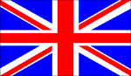
2ND BRIT 1ST CAN
AIR POWER
Jabos: +2 1st BRIT;
Carpet Bombing
RESOURCES
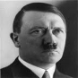
Lose 2

ORDERS: 2 Actions
+1 DRM 1st BRIT ARMY
+2 Montgomery 1st CAN ARMY
Operation Goodwood was an attack launched on 18 July 1944, by the British army to the east of the city of Caen. British VIII Corps led the attack with three armoured divisions, supported by British I Corps on the eastern flank and the Canadian II Corps on the western flank, who were launching their own attack codenamed Operation Atlantic, to capture the remainder of Caen.
When Operation Goodwood ended on 20 July, the armoured divisions had broken through the initial German defences and had advanced 7 miles before coming to a halt in front of the Bourguébus Ridge, although armoured cars had penetrated further south and over the ridge.

